**A Project report on**

# HOUSE PRICE PREDICTION

***Submitted in the partial fulfilment of the requirements for the Course Based Project of***

**BACHELOR OF TECHNOLOGY**

in

## INFORMATION TECHNOLOGY

Submitted by:

B.JEEVIKA 20071A12C5

B.SANDHYA 20071A12C6

B..KARTHIK 20071A12C7 B.SAHITHI 20071A12C8

**Under the esteemed guidance of**

**DR.Y.USHARANI**

Assistant Professor,

Dept. of Information Technology, VNRVJIET



**DEPARTMENT OF INFORMATION TECHNOLOGY**

## VNR Vignana Jyothi Institute of Engineering &Technology

(Autonomous Institute, Accredited by NAAC with ‘A++’ grade and NBA) Bachupally, Nizampet (S.O) Hyderabad-500 090,

## VNR Vignana Jyothi Institute of Engineering & Technology

Autonomous Institute, Accredited by NAAC with ‘A++’ grade and NBA

Bachupally, Nizampet (S.O.) Hyderabad- 500 090

**Department of Information Technology**

Date : 08 MAY 2022



**CERTIFICATE**

This is to certify that the project work entitled **“HOUSE PRICE PREDICTION”**is being submitted by **JEEVIKA (20071A12C5),SANDHYA(20071A12C6),B.KATHIK(20071A12C7),SAHITHI (20071A12C8)** in partial fulfilment for the award of Degree of **BACHELOR OF TECHNOLOGY** in **INFORMATION TECHNOLOGY** to the Jawaharlal Nehru Technological University, Hyderabad during the academic year 2022-23 is a record of bona-fide work carried out by them under my guidance and supervision.

The results embodied in this report have not been submitted by the students to any other University or Institution for the award of any degree or diploma.

**Project Guide Head of Department**

**DR.Y.USHARANI Dr. D.SRINIVASA RAO**

**Assistant Professor Assistant Professor Dept. of IT, Head of Department, VNRVJIET, Dept. of IT,**

**Hyderabad. VNRVJIET,**

**Hyderabad.**

## VNR Vignana Jyothi Institute of Engineering &Technology

Autonomous Institute, Accredited by NAAC with ‘A++’ grade and NBA) Bachupally, Nizampet (S.O.) Hyderabad- 500090.

**Department of Information Technology**

Date: 08 MAY 2023

**DECLARATION**

We hereby declare that the project entitled **“HOUSE PRICE PREDICTION**”submitted for the B. tech degree is my original work and the project has not formed the basis for the award of any degree, associate ship, fellowship or any other similar titles.

Signature of the Student:

B.JEEVIKA B.SANDHYA B.KARTHIK B . SAHITHI

(20071A12C5) (20071A12C6) (20071A12C7) (20071A12C8)

Place: Hyderabad Date: 08 MAY 2023

**ACKNOWLEDGEMENT**

We express our deep sense of gratitude to our beloved **President, Sri D. Suresh Babu, VNR Vignana Jyothi Institute of Engineering &Technology** for the valuable guidance and for permitting us to carry out this project.

With immense pleasure, we record our deep sense of gratitude to our beloved

**Principal, Dr. C.D. Naidu** for permitting us to carry out this project.

We express our deep sense of gratitude to our beloved professor **Dr. D. Srinivasa Rao, Associate Professor and Head, Department of Information Technology, VNR Vignana Jyothi Institute of Engineering & Technology, Hyderabad-90** for the valuable guidance and suggestions, keen interest and through encouragement extended throughout period of project work.

We take immense pleasure to express our deep sense of gratitude to our beloved Guide **B.Raswitha, Assistant Professor in Information Technology, VNR Vignana Jyothi Institute of Engineering & Technology, Hyderabad,** for her valuable suggestions and rare insights, for constant source of encouragement and inspiration throughout my project work.

We express our thanks to all those who contributed for the successful completion of our project work.

1. **JEEVIKA**
2. **KARTHIK**
3. **SANDHYA**
4. **SAHITHI**

**_**

**A Project Report on**

# HOUSE PRICE PREDICTION

***Submitted in the partial fulfilment of the requirements for the Course based project of***

**BACHELOR OF TECHNOLOGY**

in

## INFORMATION TECHNOLOGY

Submitted by

B.JEEVIKA 20071A12C5

**Under the esteemed guidance of**

**DR.Y.USHARANI**

Assistant Professor,

Dept. of Information Technology, VNRVJIET



**DEPARTMENT OF INFORMATION TECHNOLOGY**

## VNR Vignana Jyothi Institute of Engineering & Technology

(Autonomous Institute, Accredited by NAAC with ‘A++’ grade and NBA)

Bachupally, Nizampet (S.O.) Hyderabad- 500 090,

MAY 2023

**A Project Report on**

# HOUSE PRICE PREDICTION

***Submitted in the partial fulfilment of the requirements for the Course Based Project of***

**BACHELOR OF TECHNOLOGY**

in

## INFORMATION TECHNOLOGY

Submitted by

B.SANDHYA 20071A12C6

**Under the esteemed guidance of**

**DR.Y.USHARANI**

Assistant Professor,

Dept. of Information Technology, VNRVJIET



**DEPARTMENT OF INFORMATION TECHNOLOGY**

## VNR Vignana Jyothi Institute of Engineering & Technology

(Autonomous Institute, Accredited by NAAC with ‘A++’ grade and NBA)

Bachupally, Nizampet (S.O.) Hyderabad- 500 090,

MAY 2023

**A Project Report on**

# HOUSE PRICE PREDICTION

***Submitted in the partial fulfilment of the requirements for the Course based Project of***

**BACHELOR OF TECHNOLOGY**

in

## INFORMATION TECHNOLOGY

Submitted by

B.KARTHIK 20071A12C7

**Under the esteemed guidance of**

**DR.Y.USHARANI**

Assistant Professor,

Dept. of Information Technology, VNRVJIET



**DEPARTMENT OF INFORMATION TECHNOLOGY**

## VNR Vignana Jyothi Institute of Engineering & Technology

(Autonomous Institute, Accredited by NAAC with ‘A++’ grade and NBA)

Bachupally, Nizampet (S.O.) Hyderabad- 500 090.

MAY 2023

**A Project Report on**

**HOUSE PRICE PREDICTION**

***Submitted in the partial fulfilment of the requirements for the Course Based Project of***

**BACHELOR OF TECHNOLOGY**

in

## INFORMATION TECHNOLOGY

Submitted by

B.SAHITHI 20071A12C7

**Under the esteemed guidance of**

**. DR.Y.USHARANI**

Assistant Professor,

Dept. of Information Technology, VNRVJIET



**DEPARTMENT OF INFORMATION TECHNOLOGY**

## VNR Vignana Jyothi Institute of Engineering & Technology

(Autonomous Institute, Accredited by NAAC with ‘A++’ grade and NBA)

Bachupally, Nizampet (S.O.) Hyderabad- 500 090

MAY 2023

**ABSTRACT**

We propose to implement a house price prediction model of Bangalore, India. It’s a Machine Learning model which integrates Data Science and Web Development. Housing prices fluctuate on a daily basis and are sometimes exaggerated rather than based on worth. The major focus of this project is on predicting home prices using genuine factors. Here, we intend to base an evaluation on every basic criterion that is taken into account when establishing the pricing. The goal of this project is to learn Python and get experience in

ml.

**INDEX**

|  |  |  |
| --- | --- | --- |
| **S.no** | **Contents** | **Page no.** |
| 1 | **Chapter 1: Introduction** |  |
|  | * 1. Definition   2. Scope of work   3. Objective   4. Project Architecture | **1**  **1**  **1**  **2** |
| **2** | **Chapter 2: Literature Survey** | **3** |
| **3** | **Chapter 3: Methodology** |  |
|  | 3.1 Data Collection  3.2 Linear Regression  3.3 Decision Tree Regression  3.4 Classification Trees  3.5 Regression Trees  3.6 Support Vector Regression  3.7 Random Forest Regression | **4** |
| **4** | **Chapter 4 : Results** | 8 |
| **5** | **Chapter 5 : Conclusion** | **12** |
| **6** | **Chapter 6 : Future Scope** | **13** |
| **7** | **Chapter 7 : References** | **14** |

**CHAPTER 1**

**INTRODUCTION**

* 1. **Definition**

This project was made because we were intrigued and we wanted to gain hands-on experience with the Machine Learning Project.

* 1. **Scope of Work**

We are highly interested in anything related to Machine Learning, the independent project provided us with the opportunity to study and reaffirm our passion for this subject. The capacity to generate guesses, forecasts, and offer machines the ability to learn on their own is both powerful and infinite in terms of application possibilities. Machine Learning may be applied in finance, medicine, and virtually any other field. That is why we opted to base our idea on Machine Learning

**1.3 Objective**

Objective As a first project, we intended to make it as instructional as possible by tackling each stage of the machine learning process and attempting to comprehend it well. We have picked Bangalore Real Estate Prediction as a method, which is known as a "toy issue," identifying problems that are not of immediate scientific relevance but are helpful to demonstrate and practice.

The objective was to forecast the price of a specific apartment based on market pricing while accounting for various "features" that would be established in the following sections

* 1. **Project Architecture**

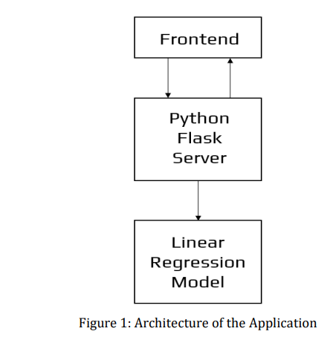

**CHAPTER2**

**Literature Survey**

Real Estate Property is not only a person's primary desire, but it also reflects a person's wealth and prestige in today's society. Real estate investment typically appears to be lucrative since property values do not drop in a choppy fashion. Changes in the value of the real estate will have an impact on many home investors, bankers, policymakers, and others. Real estate investing appears to be a tempting option for investors. As a result, anticipating the important estate price is an essential economic indicator. According to the 2011 census, the Asian country ranks second in the world in terms of the number of households, with a total of 24.67 crores. However, previous recessions have demonstrated that real estate costs cannot be seen. The expenses of significant estate property are linked to the state's economic situation. Regardless, we don't have accurate standardized approaches to live the significant estate property values. First, we looked at different articles and discussions about machine learning for housing price prediction. The title of the article is house price prediction, and it is based on machine learning and neural networks. The publication's description is minimal error and the highest accuracy. The aforementioned title of the paper is Hedonic models based on price data from Belfast infer that submarkets and residential valuation this model is used to identify over a larger spatial scale and implications for the evaluation process related to the selection of comparable evidence and the quality of variables that the values may require. Understanding current developments in house prices and homeownership are the subject of the study. In this article, they utilized a feedback mechanism or social pandemic that fosters a perception of property as an essential marketinvestment

**CHAPTER 3**

**Methodology**

**3.1 Data Collection**

The statistics were gathered from Bangalore home prices. The information includes many variables such as area type, availability, location, BHK, society, total square feet, bathrooms, and balconies

**3.2 Linear Regression**

Linear regression is a supervised learning technique. It is responsible for predicting the value of a dependent variable (Y) based on a given independent variable (X). It is theconnection between the input (X) and the output (Y). It is one of the most well-known and well-understood machine learning algorithms. Simple linear regression, ordinary least squares, Gradient Descent, and Regularization are the linear regression models.

**3.3 Decision Tree Regression**

It is an object that trains a tree-structured model to predict data in the future in order to provide meaningful continuous output. The core principles of decision trees, Maximizing Information Gain, Classification trees, and Regression trees are the processes involved in decision tree regression. The essential notion of decision trees is that they are built via recursive partitioning. Each node can be divided into child nodes, beginning with the root node, which is known as the parent node. These nodes have the potential to become the parent nodes of their resulting offspring nodes. The nodes at the informative features are specified as the maximizing information gain, to establish an objective function that is to optimize the tree learning method.

**3.4 Classification Trees**

Classification trees are used to forecast the object into classes of a categorical dependent variable based on one or more predictor variables.

**3.5 Regression Trees**

It supports both continuous and categorical input variables. Regression trees are regarded as research with various machine algorithms for the regression issue, with the Decision Tree approach providing the lowest loss. The RSquared value for the Decision Tree is 0.998, indicating that it is an excellent model. The Decision Tree was used to complete the web development.

**3.6 Support Vector Regression**

Supervised learning is linked with learning algorithms that examine data for classification and regression analysis.

**3.7 Random Forest Regression**

It is an essential learning approach for classification and regression to create a large number of decision trees. Preliminaries of decision trees are common approaches for a variety of machine learning problems. Tree learning is required for serving n off the self-produce for data mining since it is invariant despite

scaling and several other changes. The trees are grown very deep in order to learn a high regular pattern. Random forest is a method of averaging several deep decision trees trained on various portions of the same training set. This comes at the price of a slight increase in bias and some interoperability

**CHAPTER 4**

**Results**

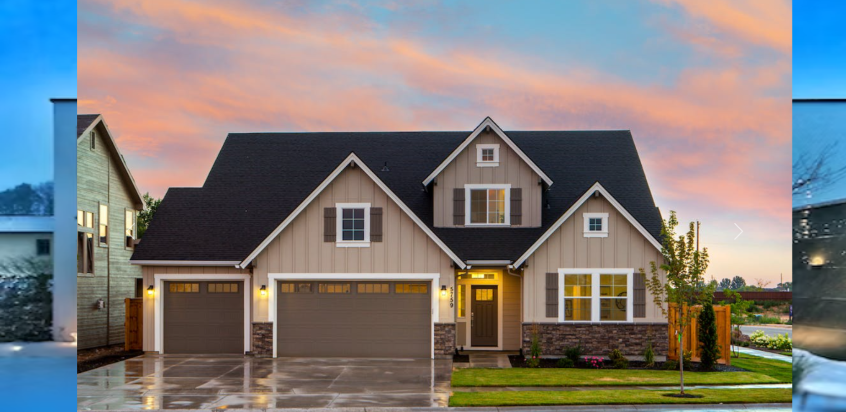

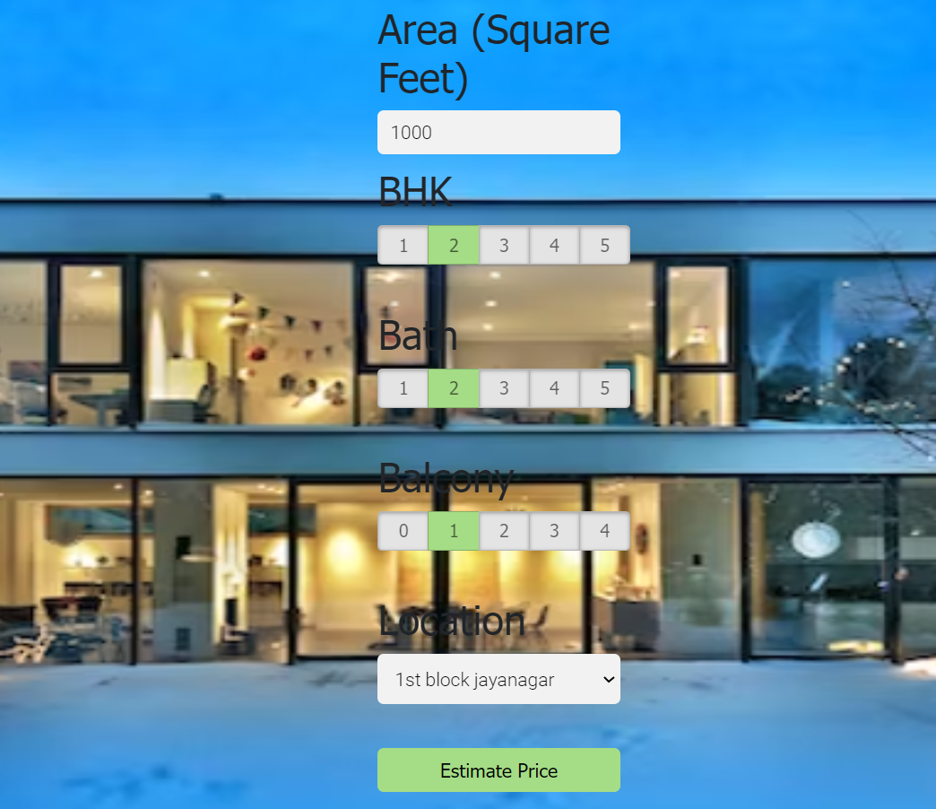

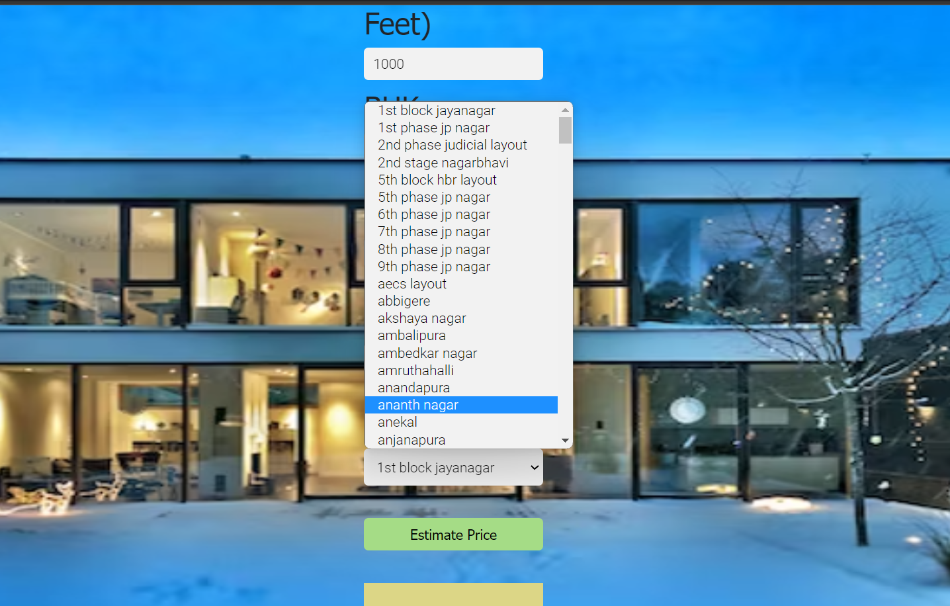

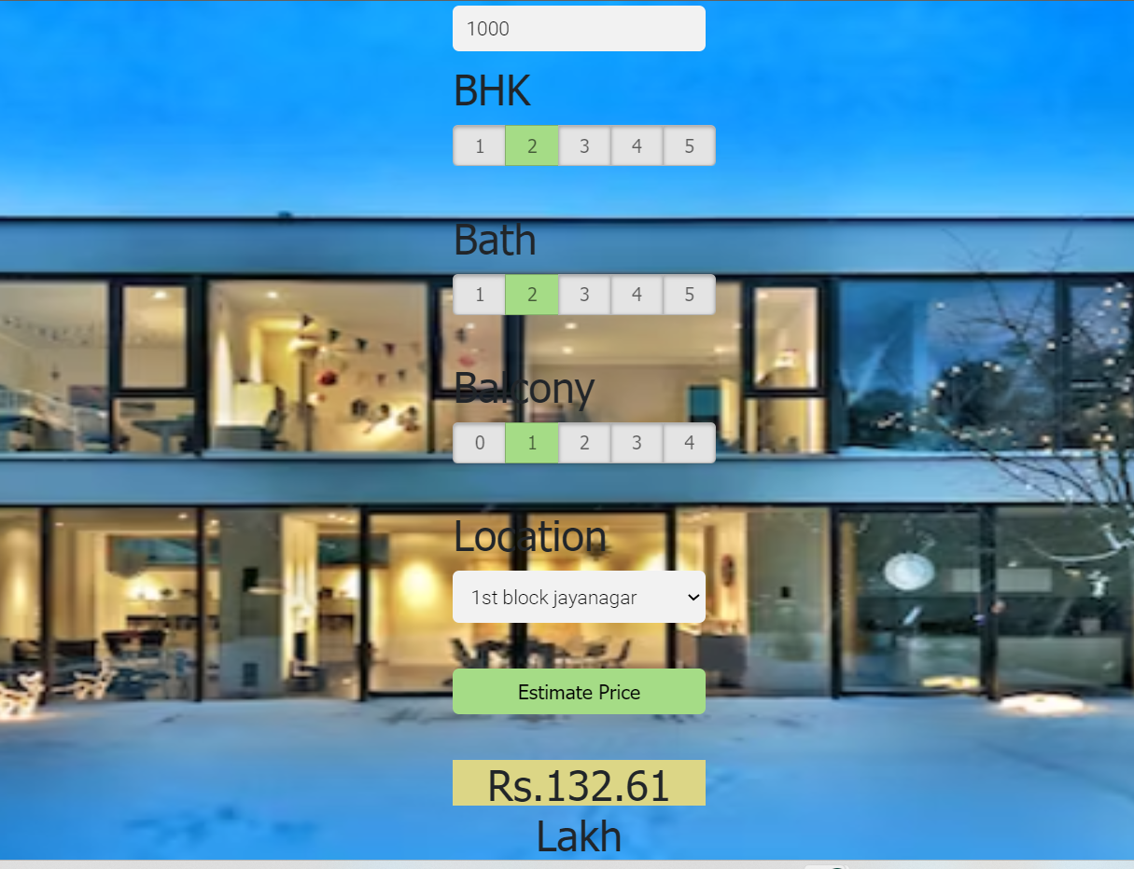

**CHAPTER 5**

**CONCLUSION**

With several characteristics, the suggested method predicts the property price in Bangalore. We experimented with different Machine Learning algorithms to get the best model. When compared to all other algorithms, the Decision Tree Algorithm achieved the lowest loss and the greatest R-squared. Flask was used to create the website.

**CHAPTER 6**

**FUTURE SCOPE**

Accuracy of the model can be improved or there can be any other model which can be developed which gives a better result when compared with the existing system.

Data sets which are taken into consideration can be improved(big in size).

**CHAPTER 7**

**REFERENCES**

[1] Model “BANGALORE HOUSE PRICE PREDICTION MODEL”

[2] Heroku “Documentation”

[3] Repository: “Web Application”

[4] Pickle ‘’Documentation’’

[5] A. Varma, A. Sarma, S. Doshi and R. Nair, "House Price Prediction Using Machine Learning and Neural Networks," 2018 Second International Conference on Inventive Communication and Computational Technologies (ICICCT), 2018, pp. 1936-1939, doi: 10.1109/ICICCT.2018.8473231.

[6] Furia, Palak, and Anand Khandare. "Real Estate Price Prediction Using Machine Learning Algorithm." eConference on Data Science and Intelligent Computing. 2020.

[7] Musciano, Chuck, and Bill Kennedy. HTML & XHTML: The Definitive Guide: The Definitive Guide. " O'Reilly Media, Inc.", 2002.

[8] Aggarwal, Shalabh. Flask framework cookbook. Packt Publishing Ltd, 2014.

[9] Grinberg, Miguel. Flask web development: developing web applications with python. " O'Reilly Media, Inc.", 2018.

[10] Middleton, Neil, and Richard Schneeman. Heroku: up and running: effortless application deployment and scaling. " O'Reilly Media, Inc.", 2013.